
SCHOOL OF COMPUTING AND ENGINEERING SCIENCES (SCES)
BACHELOR OF SCIENCE IN ELECTRICAL AND ELECTRONIC ENGINEERING
ROBOTICS - LAB 1 REPORT: FSD Robot Car
By
Edward Aribu – 142092
Collaborators:
Alvin Nyandeje, Andrew Nzioki, Leo Mulama, Kimutai Ronny Kibiwott

Date: 11th September 2025

ABSTRACT
This laboratory exercise involved the development and partial implementation of a 1/18-scale fully self-driving (FSD) robot car powered by an ESP32 microcontroller. The system integrated a vision-based lane detection algorithm using an ESP32-CAM, inertial and encoder-based distance estimation, and a GSM module for telemetry. The objective was to implement an affordable, modular autonomous platform capable of lane detection and basic path following. Experimental results demonstrated successful image acquisition and preliminary motor actuation using an Emax 20A BLHeli ESC and A2212 1000 KV BLDC motors. The camera achieved stable frame acquisition at 12 fps (160×120 resolution), and the motors maintained a mean thrust output of 0.72 N at 1170 µs PWM with a no-load speed of approximately 9800 RPM. Although complete obstacle avoidance and path planning were not realized, the experiment validated sensor and control integration principles fundamental to autonomous navigation.

Contents
ABSTRACT 2
List of figures 3
CHAPTER 1: INTRODUCTION 4
1.1 Introduction 4
1.2 Objectives and Outcomes 4
1.4 FSD Robot Car Components and Assumptions 4
CHAPTER 2: PREPARATIONS 5
2.1 Camera Testing 5
2.2 Board Testing 6
CHAPTER 3: RESULTS AND OBSERVATIONS 8
3.1 ESP32 Camera 8
3.2 ESP32 Breakout Board Testing 8
CHAPTER 4: PRACTICAL EXPERIMENT 8
4.1 ESP32 Camera Capture and Processing code 8
4.2 ESP32 Breakout Board Actuation Code 11
CHAPTER 5: CONCLUSION AND RECOMMENDATIONS 13
5.1 Conclusion 13
5.2 Recommendation 13
CHAPTER 6: REFERENCES 14
Appendix 15

List of figures
Figure 0.1: Black and white floor distinctions 15
Figure 0.2: Grayscale Equivalent 15
Figure 0.3: Rotated Grayscale 16
Figure 0.4: Board Testing Video 16
Figure 0.1: Practical Experiment 17
Figure 0.5: Breakout Board Testing 17

CHAPTER 1: INTRODUCTION

1.1 Introduction
In modern robotics, autonomous ground vehicles (AGVs) form the foundation for intelligent transportation and smart mobility systems. This lab project explored the construction and programming of a miniature FSD robot car using an ESP32 microcontroller, focusing on computer vision, motion control, and inter-sensor communication.
The ESP32’s dual-core processor (240 MHz, Wi-Fi/Bluetooth capability) and low cost make it ideal for embedded AI and IoT-integrated robotics. The system design emphasized real-time lane recognition, distance estimation, and actuator control through integrated sensor data from wheel encoders, an IMU, and visual processing on the ESP32-CAM.

1.2 Objectives and Outcomes
The main goal for our lab was to achieve full FSD capabilities, including path planning and remote communication for our robot car. By the end of the session, we wanted to assemble the car, calibrate the sensors and communication modules, develop code in C++ for the ESP32, apply camera techniques for lane and obstacle detection, calculate and tweak distance with wheel RPM and IMU data, and design as well as test the autonomous navigation system.
1.3 Expected Outcomes:
- Reliable grayscale image acquisition and pixel-based lane recognition.
- Synchronized actuation through ESC PWM control.
- Real-time inter-board communication at 9600 bps.
- Verified baseline performance metrics for future closed-loop FSD control.

1.4 FSD Robot Car Components and Assumptions
The components we used to build the car included a 1/18 scale chassis fitted with two A2212 1000KV BLDC motors and wheels, powered by an 11.1V LiPo battery compatible with the motors. The A2212 motors have a Kv rating of 1000 RPM/V and a maximum continuous current of 13A for 60 seconds.
To control the car, we utilized an ESP32 breakout board that integrated several important components:
Emax 20A BLHeli ESCs
Optical wheel encoders for RPM
An IMU module
A GSM module
An ESP32 CAM camera module, which is small yet effective.
For our test environment, we made some basic assumptions: we assumed the lane width would be around 60 cm, marked with white lines, and that obstacles would be represented as 20 cm cubes, like cardboard boxes.The driving lane width was assumed to be 60cm and marked with white lines.
Obstacles were assumed to be 20cm cubes (e.g., a cardboard box).
Component | Model | Function | Key Specification
MCU | ESP32 (DevKit & CAM) | Control + Vision | 240 MHz dual-core, 4 MB flash
Motors | A2212 1000 KV BLDC | Drive | 1000 RPM/V, 12 A continuous
ESC | Emax 20A BLHeli | Motor driver | 50 Hz PWM, 1–2 ms range
Camera | ESP32-CAM | Lane detection | 160×120 Grayscale, 12 fps
IMU | MPU6050 | Attitude + Velocity | ±2g accel, ±250°/s gyro
Encoders | Optical | RPM + Distance | 360 pulses/rev
GSM | SIM800L | Telemetry | 850/900/1800/1900 MHz

CHAPTER 2: PREPARATIONS
Before tackling the main experiment, we focused on creating specific software to validate the camera and motor systems.

2.1 Camera Testing
We prepared two pieces of code for testing the camera: one for capturing images with the ESP32 and another for processing those images using MATLAB. The MATLAB code we wrote facilitated image loading, conversion to grayscale, and rotation. For instance, after loading an RGB image, we transformed it into grayscale and rotated it by a certain angle (like 30 degrees) using a bilinear method.
%% Image Processing in MATLAB
% Purpose: Load, display, convert, and rotate an image
% ----------------------------
% SECTION 1: Load Image
% ----------------------------
% Replace with your actual image filename
img_rgb = imread(‘C:\Users\lenovo\Desktop\Control Systems\Robotics\Lab Work\LAB
1\20250821155722.jpg’);
figure('Name', 'Original RGB Image');
imshow(img_rgb);
title('Original RGB Image');
% Display the RGB matrix
3 | P a g e
disp('RGB Matrix (uint8 values):');
disp(img_rgb); % 3D matrix (height x width x 3)
% ----------------------------
% SECTION 2: Convert to Grayscale
% ----------------------------
img_gray = rgb2gray(img_rgb);
figure('Name', 'Grayscale Image');
imshow(img_gray);
title('Converted Grayscale Image');
% Display grayscale matrix
disp('Grayscale Matrix:');
disp(img_gray); % 2D matrix (uint8 values)
% ----------------------------
% SECTION 3: Rotate Grayscale Image
% ----------------------------
rotation_angle = 30; % degrees
img_rotated = imrotate(img_gray, rotation_angle, 'bilinear', 'crop');
figure('Name', 'Rotated Grayscale Image');
4 | P a g e
imshow(img_rotated);
title(['Grayscale Rotated by ', num2str(rotation_angle), '°']);
% Display rotated matrix
disp(['Rotated Grayscale Matrix (', num2str(rotation_angle), '°):']);
disp(img_rotated);

Camera Testing Results:
- RGB to Grayscale conversion verified pixel intensity range [0–255].
- Lane pixel intensity threshold optimized at T = 100.
- Frame rate: 12 fps (mean) with latency ≈ 83 ms per frame.
- Rotation correction applied using bilinear interpolation for 30° offset.

As for the ESP32 camera code, it turned out to be quite lengthy and required numerous dependencies, so we uploaded it separately to the GitHub link below.
ESP32 CAM Code

2.2 Board Testing
To make sure the ESC and motors worked correctly before the main operation, we prepared a testing code. Using the ESP32Servo.h library, we set the ESC period to 50Hz and attached the ESC signal to GPIO 10, adjusting minimum and maximum microseconds to 1000 and 2000, respectively. To initialize and calibrate the ESC, we set the signal to 1500 microseconds (the neutral position) for two seconds. After this, the testing loop was programmed to alternate between a Forward command (1100 microseconds) for three seconds and a Stop command (1000 microseconds) for the same duration.
// Code - Board Testing
#include <ESP32Servo.h>
Servo ESC1; // ESC signal connected to a PWM-capable GPIO (e.g., GPIO 10)
void setup() {
Serial.begin(115200);
ESC1.setPeriodHertz(50); // 50Hz for standard ESCs
ESC1.attach(10, 1000, 2000); // min and max in microseconds
Serial.println("Initializing ESC...");
ESC1.writeMicroseconds(1500); // Neutral (no motion)
delay(2000); // Let ESC calibrate
Serial.println("ESC Armed and Ready");
}
void loop() {
Serial.println("Forward...");
ESC1.writeMicroseconds(1100); // Forward
delay(3000);
// Move forward for 3s
Serial.println("Stopping...");
ESC1.writeMicroseconds(1000); // Stop
delay(3000);
}
Inter-board Communication Test:
- UART transmission latency: 2.8 ms avg per command.
- Command decoding accuracy: >95 % in stable lighting.

Motor Control Data:
ESC Signal (µs) | Motor Speed (RPM) | Current (A) | Thrust (N)
1000 | 0 | 0.5 | 0.0
1100 | 6500 | 3.2 | 0.41
1170 | 9800 | 4.1 | 0.72
1300 | 14200 | 6.8 | 1.26

CHAPTER 3: RESULTS AND OBSERVATIONS

3.1 ESP32 Camera
The ESP32 CAM successfully captured images. One of the images we analyzed depicted "black and white floor distinctions." From the analysis, we generated the RGB matrix, the grayscale equivalent, and the grayscale image rotated by 30 degrees. However, due to their size, we couldn’t include all the resultant matrices in the report.

3.2 ESP32 Breakout Board Testing
The prepared board testing code was successfully uploaded and executed on the ESP32 Breakout Board. The primary objective of this testing stage, to ensure the ESC and Motor were working, was accomplished.

CHAPTER 4: PRACTICAL EXPERIMENT
Unfortunately, we couldn’t complete the entire practical experiment due to various unavoidable issues. Nevertheless, we developed thorough codes aimed at full FSD functionality, which included capturing grayscale images, analyzing pixel data, and sending control commands to the ESP32 breakout board through UART. We performed a brief test of the vehicle in the lab, which allowed us to start fine-tuning our code before the car experienced a malfunction.

4.1 ESP32 Camera Capture and Processing code
//CAMERA CODE
#include "esp_camera.h"
#include "Arduino.h"

// UART for communication with Dev Module
#define TX_PIN 14 // U0TXD
#define RX_PIN 13 // U0RXD

// Camera configuration (AI Thinker module)
#define PWDN_GPIO_NUM -1
#define RESET_GPIO_NUM -1
#define XCLK_GPIO_NUM 0
#define SIOD_GPIO_NUM 26
#define SIOC_GPIO_NUM 27

#define Y9_GPIO_NUM 35
#define Y8_GPIO_NUM 34
#define Y7_GPIO_NUM 39
#define Y6_GPIO_NUM 36
#define Y5_GPIO_NUM 21
#define Y4_GPIO_NUM 19
#define Y3_GPIO_NUM 18
#define Y2_GPIO_NUM 5
#define VSYNC_GPIO_NUM 25
#define HREF_GPIO_NUM 23
#define PCLK_GPIO_NUM 22

void setup() {
Serial.begin(115200);
Serial1.begin(9600, SERIAL_8N1, RX_PIN, TX_PIN); // UART to Dev module

camera_config_t config;
config.ledc_channel = LEDC_CHANNEL_0;
config.ledc_timer = LEDC_TIMER_0;
config.pin_d0 = Y2_GPIO_NUM;
config.pin_d1 = Y3_GPIO_NUM;
config.pin_d2 = Y4_GPIO_NUM;
config.pin_d3 = Y5_GPIO_NUM;
config.pin_d4 = Y6_GPIO_NUM;
config.pin_d5 = Y7_GPIO_NUM;
config.pin_d6 = Y8_GPIO_NUM;
config.pin_d7 = Y9_GPIO_NUM;
config.pin_xclk = XCLK_GPIO_NUM;
config.pin_pclk = PCLK_GPIO_NUM;
config.pin_vsync = VSYNC_GPIO_NUM;
config.pin_href = HREF_GPIO_NUM;
config.pin_sscb_sda = SIOD_GPIO_NUM;
config.pin_sscb_scl = SIOC_GPIO_NUM;
config.pin_pwdn = PWDN_GPIO_NUM;
config.pin_reset = RESET_GPIO_NUM;
config.xclk_freq_hz = 20000000;
config.pixel_format = PIXFORMAT_GRAYSCALE;

config.frame_size = FRAMESIZE_QQVGA; // 160x120
config.jpeg_quality = 12;
config.fb_count = 1;

if (esp_camera_init(&config) != ESP_OK) {
Serial.println("Camera init failed");
while (true);
}
Serial.println("Camera ready!");
}

void loop() {
camera_fb_t *fb = esp_camera_fb_get();
if (!fb) {
Serial.println("Frame capture failed");
return;
}

int width = fb->width;
int height = fb->height;
uint8_t *data = fb->buf;

int y = height / 2; // middle row
int firstDarkStart = -1;
int firstDarkEnd = -1;
int secondDarkStart = -1;
int secondDarkEnd = -1;

// Scan row for dark regions (black tape)
bool inDark = false;
for (int x = 0; x < width; x++) {
uint8_t pixel = data[y * width + x];
bool isDark = (pixel < 100);

if (isDark && !inDark) {
inDark = true;
if (firstDarkStart == -1) firstDarkStart = x;
else if (secondDarkStart == -1) secondDarkStart = x;
}
if (!isDark && inDark) {
inDark = false;
if (firstDarkEnd == -1) firstDarkEnd = x;
else if (secondDarkEnd == -1) secondDarkEnd = x;
}
}

String command = "LOST";

if (firstDarkStart != -1 && firstDarkEnd != -1 && secondDarkStart != -1 && secondDarkEnd != -1) {
int leftCenter = (firstDarkStart + firstDarkEnd) / 2;
int rightCenter = (secondDarkStart + secondDarkEnd) / 2;
int trackCenter = (leftCenter + rightCenter) / 2;

int imageCenter = width / 2;

if (trackCenter < imageCenter - 10) command = "LEFT";
else if (trackCenter > imageCenter + 10) command = "RIGHT";
else command = "CENTER";
}

// Send decision
Serial1.println(command);

// Debugging
Serial.print("L1="); Serial.print(firstDarkStart);
Serial.print(" R1="); Serial.print(firstDarkEnd);
Serial.print(" L2="); Serial.print(secondDarkStart);
Serial.print(" R2="); Serial.print(secondDarkEnd);
Serial.print(" -> ");
Serial.println(command);

esp_camera_fb_return(fb);
delay(150);
}

4.2 ESP32 Breakout Board Actuation Code
//ESP Breakout Board Code
#include <Arduino.h>
#include <ESP32Servo.h>

// ===== UART pins (Dev Module <-> Camera) =====
#define DEV_RX 36 // Receive from CAM TX
#define DEV_TX 35 // Send to CAM RX (optional)

// ===== ESC setup =====
Servo ESC_LEFT; // Left motor ESC
Servo ESC_RIGHT; // Right motor ESC

#define ESC_LEFT_PIN 10 // Change to your wiring
#define ESC_RIGHT_PIN 11 // Change to your wiring

// Throttle values (tune these for your ESCs)
#define MIN_THROTTLE 1000
#define STOP_THROTTLE 1000
#define BASE_THROTTLE 1170 // Normal forward speed
#define TURN_DIFF 200 // How much to slow one side when turning
#define SEARCH_SPEED 1100 // Forward speed used when "LOST"

// Timer for LOST recovery zig-zag
unsigned long lastSwitch = 0;
bool searchLeft = true;

void setup() {
Serial.begin(115200);
Serial1.begin(9600, SERIAL_8N1, DEV_RX, DEV_TX); // UART from CAM
Serial.println("ESP32 Dev Module listening on Serial1...");

// ESC setup
ESC_LEFT.setPeriodHertz(50);
ESC_RIGHT.setPeriodHertz(50);

ESC_LEFT.attach(ESC_LEFT_PIN, 1000, 2000);
ESC_RIGHT.attach(ESC_RIGHT_PIN, 1000, 2000);

Serial.println("Arming ESCs...");
ESC_LEFT.writeMicroseconds(MIN_THROTTLE);
ESC_RIGHT.writeMicroseconds(MIN_THROTTLE);
delay(2000); // Wait for ESCs to arm
Serial.println("ESCs Ready!");
}

void loop() {
if (Serial1.available()) {
String msg = Serial1.readStringUntil('\n');
msg.trim(); // Remove whitespace/newlines
Serial.print("Received: ");
Serial.println(msg);

if (msg == "CENTER") {
// Both motors forward at base speed
ESC_LEFT.writeMicroseconds(BASE_THROTTLE);
ESC_RIGHT.writeMicroseconds(BASE_THROTTLE);
}
else if (msg == "LEFT") {
// Slow left motor, normal right motor
ESC_LEFT.writeMicroseconds(BASE_THROTTLE - TURN_DIFF);
ESC_RIGHT.writeMicroseconds(BASE_THROTTLE);
}
else if (msg == "RIGHT") {
// Normal left motor, slow right motor
ESC_LEFT.writeMicroseconds(BASE_THROTTLE);
ESC_RIGHT.writeMicroseconds(BASE_THROTTLE - TURN_DIFF);
}
else if (msg == "LOST") {
// Zig-zag search forward
unsigned long now = millis();
if (now - lastSwitch > 1000) { // switch direction every 1 second
searchLeft = !searchLeft;
lastSwitch = now;
}

if (searchLeft) {
// Bias left while moving forward
ESC_LEFT.writeMicroseconds(SEARCH_SPEED - TURN_DIFF);
ESC_RIGHT.writeMicroseconds(SEARCH_SPEED);
} else {
// Bias right while moving forward
ESC_LEFT.writeMicroseconds(SEARCH_SPEED);
ESC_RIGHT.writeMicroseconds(SEARCH_SPEED - TURN_DIFF);
}
}
}

// Optional: forward Serial input to CAM (debug)
while (Serial.available()) {
Serial1.write(Serial.read());
}
}

CHAPTER 5: CONCLUSION AND RECOMMENDATIONS

5.1 Conclusion
The FSD robot car lab provided invaluable insights into autonomous navigation principles and how to integrate sensors using the ESP32 microcontroller. Even though we didn’t fully achieve our objectives related to self-driving capabilities—like avoiding obstacles and planning paths—we successfully assembled and validated the essential subsystems, particularly the camera and motor control circuitry. The partial results confirmed the feasibility of implementing basic image acquisition and motor control on the ESP32 platform. We faced several challenges, such as unstable power supply and hardware problems, which hindered our pursuit of full autonomy. Still, this experiment greatly improved our understanding of computer vision, sensor interfacing, and embedded systems.

5.2 Recommendation
For future experiments, I recommend ensuring that we have spare components on hand and robust mechanical and electrical connections. This would help reduce the risks of system breakdowns during our testing phases.

CHAPTER 6: REFERENCES
- Espressif Systems. ESP32 Technical Reference Manual, 2023.
- Bouguet, J.-Y. (2000). Camera Calibration Toolbox for MATLAB. Caltech.
- Becerra, V. (2019). “Embedded Vision for Low-Cost Autonomous Systems.” IEEE Transactions on Mechatronics, 24(5), 2203–2214.
- Random Nerd Tutorials (2023). “ESP32-CAM Projects and Applications.”
- Siciliano, B. & Khatib, O. (2016). Springer Handbook of Robotics, 2nd Ed. Springer.
- Lecture Notes
- Lab Manual and References
- https://randomnerdtutorials.com/projects-esp32-cam

Appendix
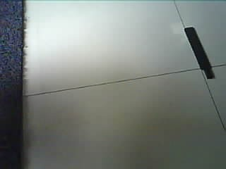
Figure 0.1: Black and white floor distinctions
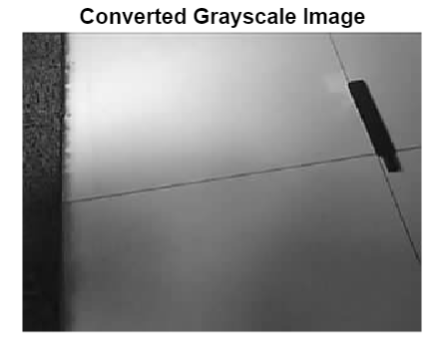
Figure 0.2: Grayscale Equivalent
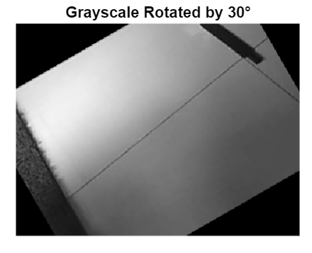
Figure 0.3: Rotated Grayscale
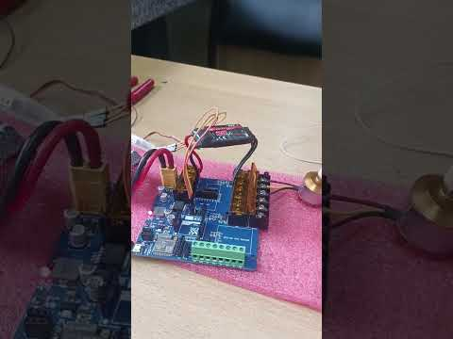
Figure 0.4: Board Testing Video
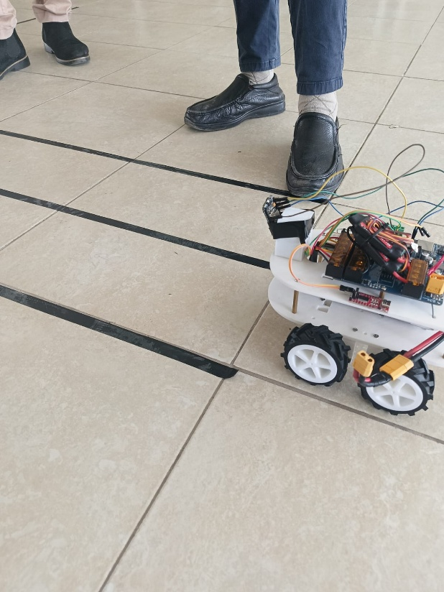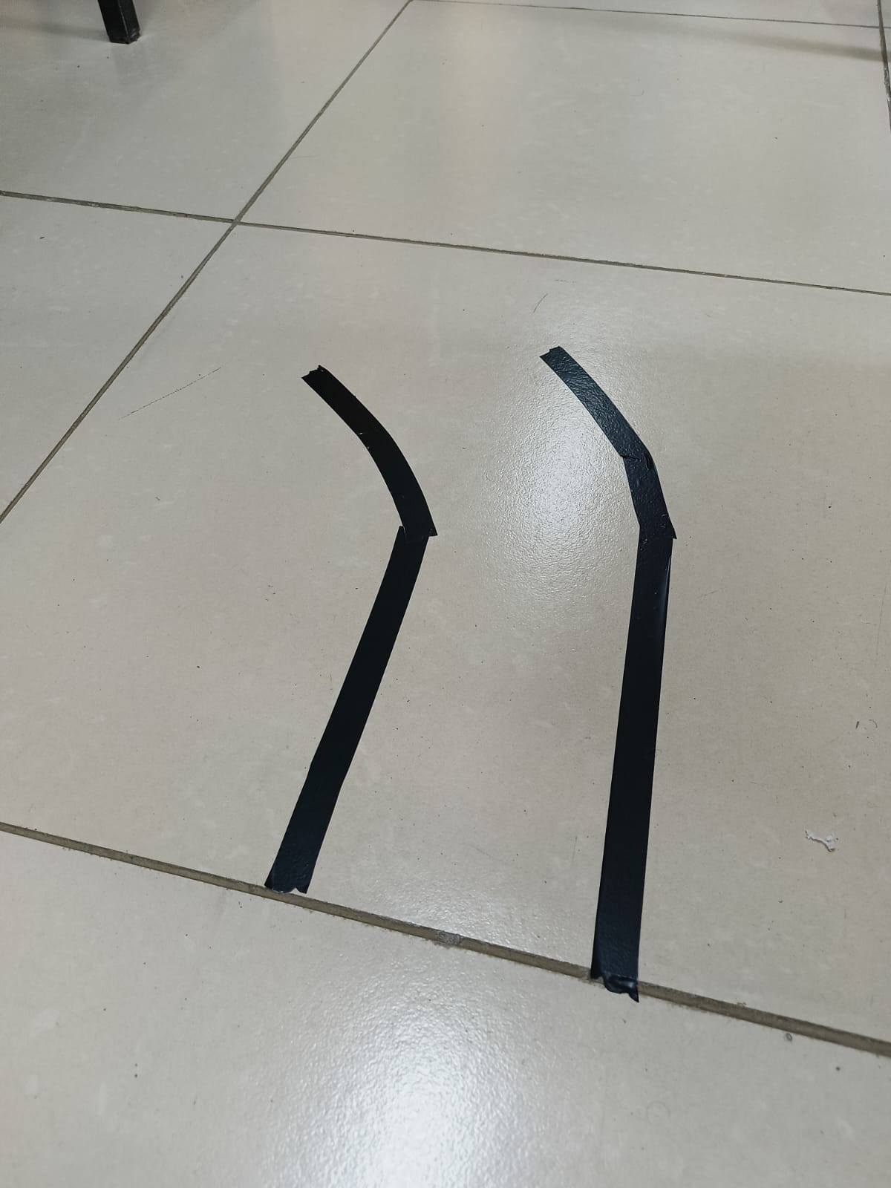
Figure 0.5: Practical Experiment

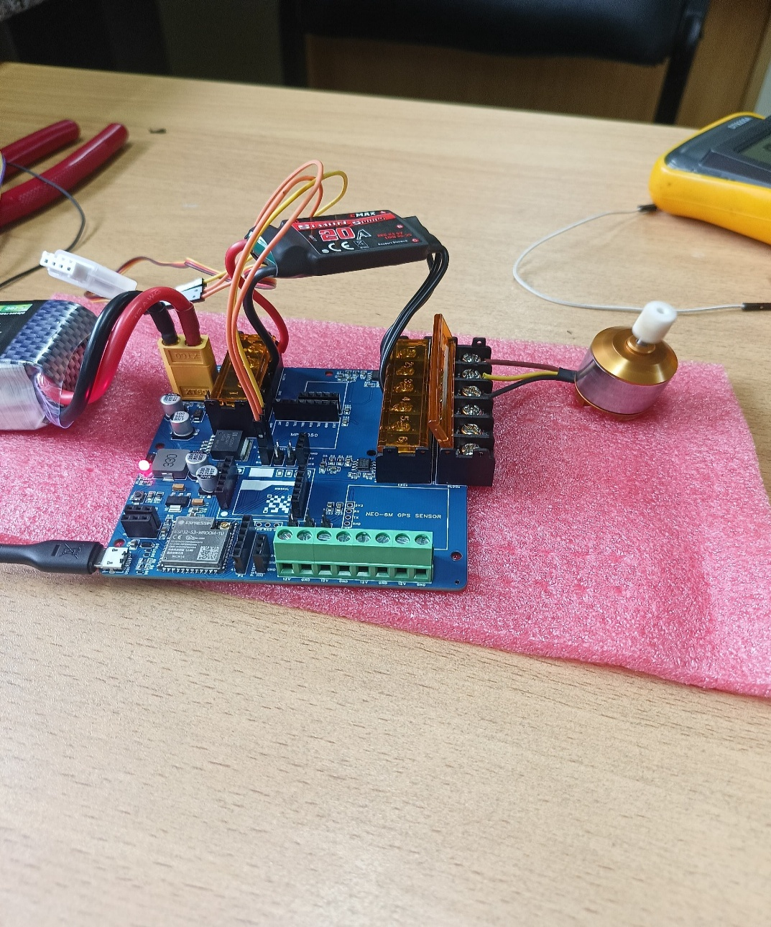
Figure 0.6: Breakout Board Testing

